If we want to go from city "A" to city "B", there can be many ways of doing this. We can go by flight, by bus, by train and also by bicycle. Depending on the availability and convenience, we choose the one which suits us. Similarly, in computer science there are multiple algorithms to solve a problem. When we have more than one algorithm to solve a problem, we need to select the best one. Performance analysis helps us to select the best algorithm from multiple algorithms to solve a problem.
When there are multiple alternative algorithms to solve a problem, we analyse them and pick the one which is best suitable for our requirements. The formal definition is as follows...
Performance of an algorithm is a process of making evaluative judgments about algorithms.
It can also be defined as follows...
Performance of an algorithm means predicting the resources which are required to an algorithm to perform its task.
That means when we have multiple algorithms to solve a problem, we need to select a suitable algorithm to solve that problem.
We compare all algorithms with each other which are solving the same problem, to select the best algorithm. To compare algorithms, we use a set of parameters or set of elements like memory required by that algorithm, execution speed of that algorithm, easy to understand, easy to implement, etc.,
Generally, the performance of an algorithm depends on the following elements...
- Whether that algorithm is providing the exact solution for the problem?
- Is it easy to understand?
- Is it easy to implement?
- How much space (memory) does it require to solve the problem?
- How much time does it take to solve the problem? Etc.,
When we want to analyse an algorithm, we consider only the space and time required by that particular algorithm and we ignore all remaining elements.
Based on this information, performance analysis of an algorithm can also be defined as follows...
Performance analysis of an algorithm is the process of calculating space required by that algorithm and time required by that algorithm.
Performance analysis of an algorithm is performed by using the following measures...
- Space required completing the task of that algorithm (Space Complexity). It includes program space and data space
- Time required to complete the task of that algorithm (Time Complexity)
When we design an algorithm to solve a problem, it needs some computer memory to complete its execution. For any algorithm, memory is required for the following purposes...
- Memory required to store program instructions
- Memory required to store constant values
- Memory required to store variable values
- And for few other things
Space complexity of an algorithm can be defined as follows...
Total amount of computer memory required by an algorithm to complete its execution is called as space complexity of that algorithm
Generally, when a program is under execution it uses the computer memory for THREE reasons. They are as follows...
- Instruction Space: It is the amount of memory used to store compiled version of instructions.
- Environmental Stack: It is the amount of memory used to store information of partially executed functions at the time of function call.
- Data Space: It is the amount of memory used to store all the variables and constants.
NOTE
☀ When we want to perform analysis of an algorithm based on its Space complexity, we consider only Data Space and ignore Instruction Space as well as Environmental Stack.
That means we calculate only the memory required to store Variables, Constants, Structures, etc.,
To calculate the space complexity, we must know the memory required to store different datatype values (according to the compiler). For example, the C Programming Language compiler requires the following...
- 4 bytes to store Integer value,
- 4 bytes to store Floating Point value,
- 1 byte to store Character value,
- 6 (OR) 8 bytes to store double value
Example 1
Consider the following piece of code...

int square(int a)
{
return a*a;
}
In the above piece of code, it requires 4 bytes of memory to store variable 'a' and another 4 bytes of memory is used for return value.
That means, totally it requires 8 bytes of memory to complete its execution. And this 8 bytes of memory is fixed for any input value of 'a'. This space complexity is said to be Constant Space Complexity.
If any algorithm requires a fixed amount of space for all input values then that space complexity is said to be Constant Space Complexity.

Example 2
Consider the following piece of code...
int sum(int A[], int n)
{
int sum = 0, i;
for(i = 0; i < n; i++)
sum = sum + A[i];
return sum;
}

In above piece of code it requires-
'n*4' bytes of memory to store array variable 'a[]'
4 bytes of memory for integer parameter 'n'
8 bytes of memory for local integer variables 'sum' and 'i' (4 bytes each)
4 bytes of memory for return value.
That means, totally it requires '4n+16' bytes of memory to complete its execution. Here, the amount of memory depends on the input value of 'n'. This space complexity is said to be Linear Space Complexity.
If the amount of space required by an algorithm is increased with the increase of input value, then that space complexity is said to be Linear Space Complexity
What is Time complexity?
Every algorithm requires some amount of computer time to execute its instruction to perform the task. This computer time required is called time complexity.
Time complexity of an algorithm can be defined as follows...
The time complexity of an algorithm is the total amount of time required by an algorithm to complete its execution.
Generally, the running time of an algorithm depends upon the following...
- Whether it is running on a Single processor machine or Multi processor machine.
- Whether it is a 32 bit machine or 64 bit machine
- Read and Write speed of the machine.
- The time it takes to perform Arithmetic operations, logical operations, return value and assignment operations etc.,
- Input data
NOTE
**When we calculate time complexity of an algorithm, we consider only input data and ignore the remaining things, as they are machine dependent. We check only, how our program is behaving for the different input values to perform all the operations like Arithmetic, Logical, Return value and Assignment etc.,
Calculating Time Complexity of an algorithm based on the system configuration is a very difficult task because the configuration changes from one system to another system. To solve this problem, we must assume a model machine with specific configuration. So, we are able to calculate generalized time complexity according to that model machine.
To calculate the time complexity of an algorithm, we need to define a model machine. Let us assume a machine with the following configuration...
- Single processor machine
- 32 bit Operating System machine
- It performs sequential execution
- It requires 1 unit of time for Arithmetic and Logical operations
- It requires 1 unit of time for Assignment and Return value
- It requires 1 unit of time for Read and Write operations
Now, we calculate the time complexity of following example code by using the above defined model machine...
Example 1
Consider the following piece of code...
int sum(int a, int b)
{
return a+b;
}
In the above sample code, it requires 1 unit of time to calculate a+b and 1 unit of time to return the value. That means, totally it takes 2 units of time to complete its execution. And it does not change based on the input values of a and b. That means for all input values, it requires the same amount of time i.e. 2 units.
If any program requires a fixed amount of time for all input values then its time complexity is said to be Constant Time Complexity.
Example 2
Consider the following piece of code...
int sum(int A[], int n)
{
int sum = 0, i;
for(i = 0; i < n; i++)
sum = sum + A[i];
return sum;
}
For the above code, time complexity can be calculated as follows...
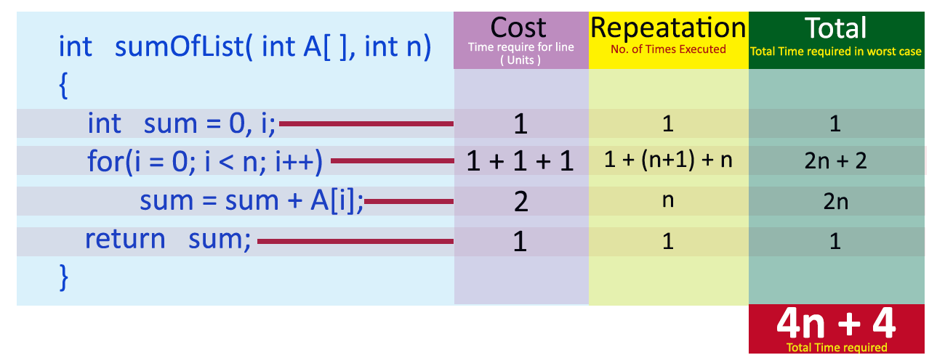
In above calculation Cost is the amount of computer time required for a single operation in each line.
Repetition is the amount of computer time required by each operation for all its repetitions.
Total is the amount of computer time required by each operation to execute.
So the above code requires '4n+4' Units of computer time to complete the task. Here the exact time is not fixed. And it changes based on the n value. If we increase the n value then the time required also increases linearly.
Totally it takes '4n+4' units of time to complete its execution and it is Linear Time Complexity.
If the amount of time required by an algorithm is increased with the increase of input value then that time complexity is said to be Linear Time Complexity.

